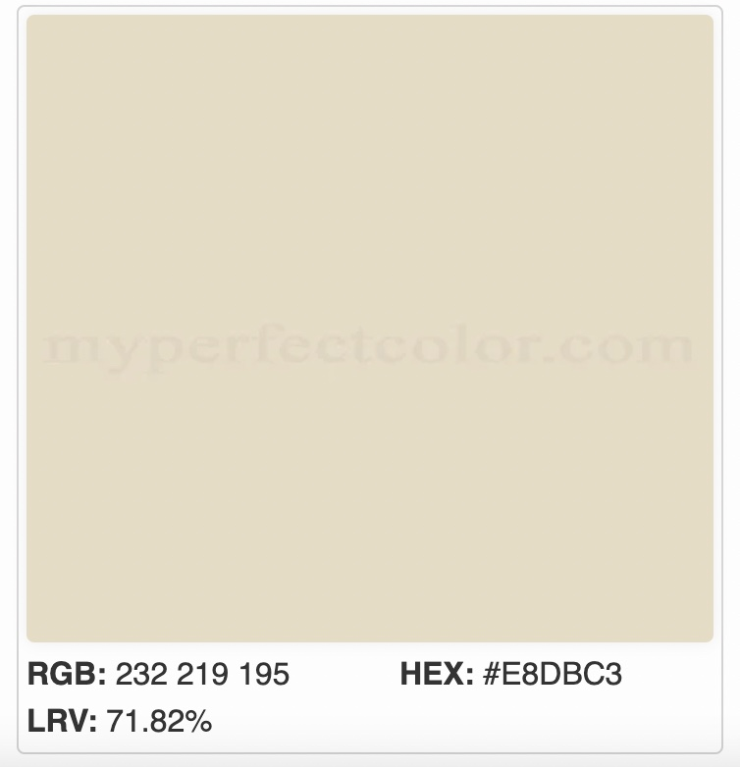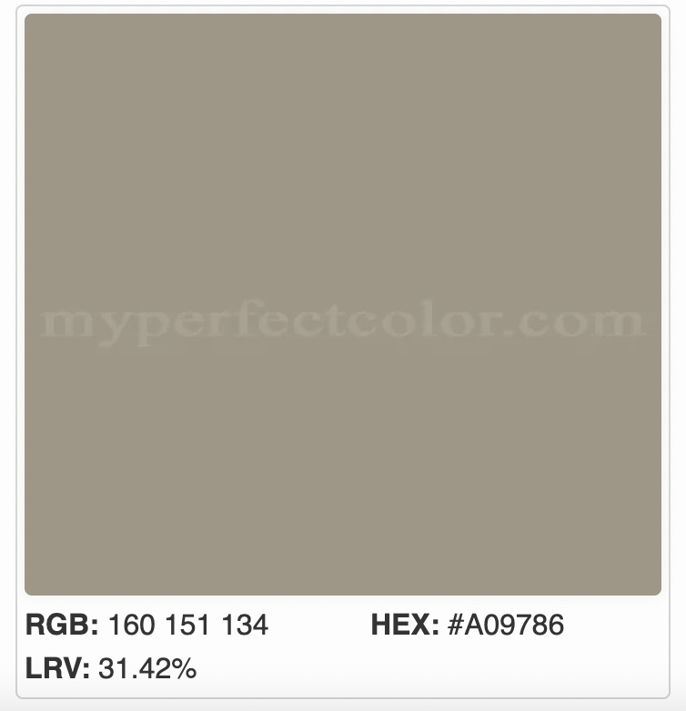
James Hardie Sail Cloth
Siding
James Hardie Monterey Taupe
Trim
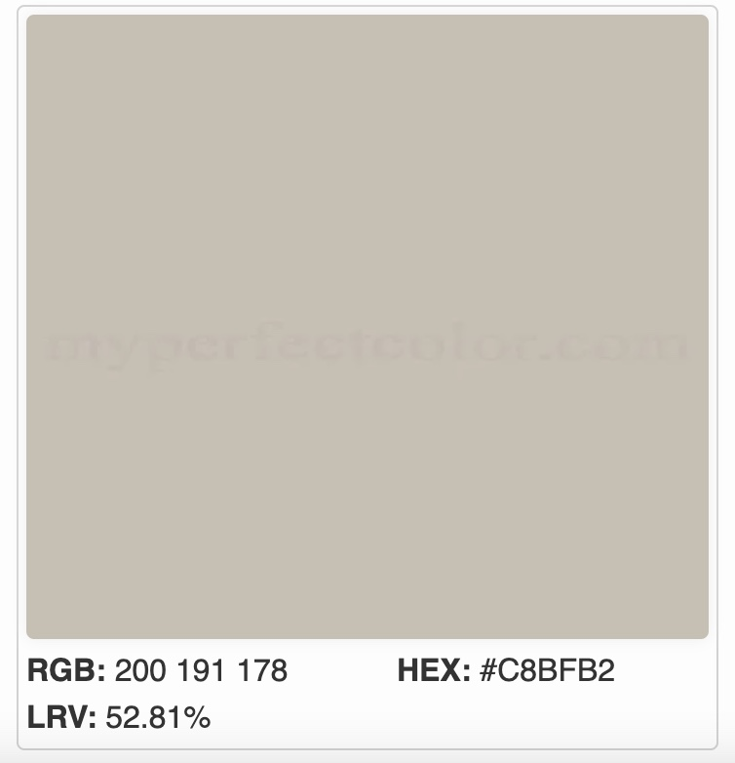
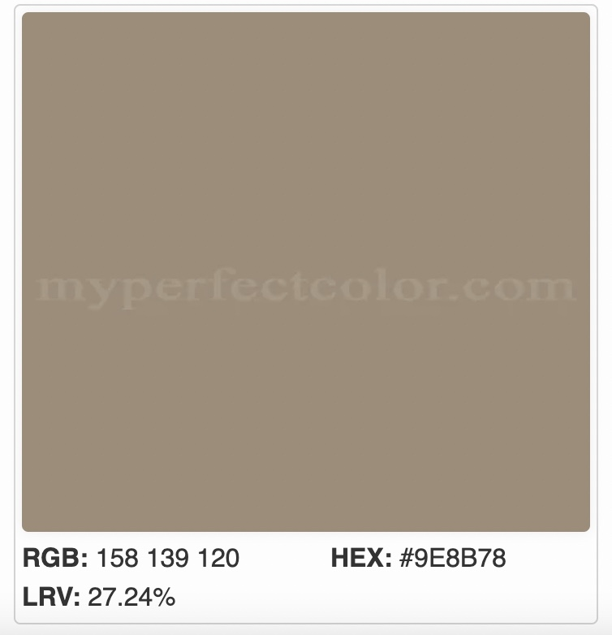
James Hardie Cobblestone
Trim
James Hardie Khaki Brown
Siding

